Three distinct patterns of mental health response following accidents in alpine sports – a follow-up study of individuals treated at a tertiary trauma center

Manuscript

Hanna Salvotti MD (1), Piotr Tymoszuk (2), PhD, Mathias Ströhle (3), MD, Peter Paal, MD (4), Hermann Brugger, MD (5), Martin Faulhaber, PhD (6), Nicola Kruijer, MD (7), Barbara Sperner-Unterweger, MD (8), Katharina Hüfner, MD (8)

2023-04-18

1. Department of Neurosurgery, University Hospital of Regensburg, Regensburg Germany Formerly: Department of Psychiatry, Psychotherapy, Psychosomatics and Medical Psychology, University Hospital for Psychiatry II, Medical University of Innsbruck, Innsbruck, Austria

2. Data Analysis as a Service Tirol, Innsbruck, Austria

3. Department of Anesthesiology and Critical Care Medicine, Bezirkskrankenhaus Kufstein, Kufstein, Austria

4. Department of Anesthesiology and Intensive Care Medicine. St. John of God Hospital, Paracelsus Medical University, Salzburg, Austria. President Austrian Board of Mountain Safety (Österreichisches Kuratorium fur Alpine Sicherheit), lnnsbruck, Austria. Vice-president, Austrian Society of Mountain and High-Altitude Medicine, Mieming, Austria. Research lead, lnternational Commission for Mountain Emergency Medicine (ICAR), Kloten, Switzerland.

5. EURAC Research, lnstitute for Mountain Emergency Medicine, Bolzano/ Bozen, ltaly. President lnternational Society of Mountain Medicine (ISMM), Past President ICAR MedCom

6. Department of Sport Science, University lnnsbruck, lnnsbruck, Austria

7. Department of Orthopedics and Traumatology, Innsbruck Medical University, Innsbruck, Austria

8. Department of Psychiatry, Psychotherapy, Psychosomatics and Medical Psychology, University Hospital for Psychiatry II, Medical University of Innsbruck, Innsbruck, Austria

✉ Correspondence: [Katharina Hüfner, MD <katharina.huefner@tirol-kliniken.at>](mailto:katharina.huefner@tirol-kliniken.at)

# Abstract

**Background:** The restorative effect of natural environments on mental and physical health is increasingly recognized by medical professionals and the general population. Therefore many individuals travel to alpine regions for mountain sports. These activities can lead to accidents. The consequences of such accidents on mental health have not been characterized. We aimed to identify symptoms of post-traumatic stress, post-traumatic growth and further facets of mental health following accidents during sport in the mountains.

**Methods:** Data from 307 adults treated at the Innsbruck University Hospital (Austria) for an injury related to a mountain sport accident between 01.01.2018 and 31.12.2020 were analyzed. Symptoms of anxiety, depression, somatization and panic disorder (PHQ questionnaire), resilience (RS-13), sense of coherence (SOC-9L), quality of life (EUROHIS-QOL), post-traumatic growth (PTGI) and post-traumatic stress disorder (PCL-5) were recorded in a cross sectional online survey along with sociodemographic information. Clinical data were extracted from electronic health records. The mental health response to the accident was defined by semi-supervised medoid clustering. Models of cluster assignment based on characteristics available during acute treatment were developed by the random forest algorithm.

**Results:** 18% of participants scored on at least one diagnostic criterion of post traumatic stress disorder (PTSD) and 4 individuals (1.1%) reached the cut off indicating manifest PTSD. Three equally sized clusters of mental health responses were identified characterized by (1) a prevalence of post-traumatic stress symptoms, (2) post traumatic growth and (3) a “neutral” response to the accident. Symptoms of mental disorders together with low resilience, sense of coherence and quality of life were almost exclusively found in the post-traumatic stress cluster. The post-traumatic stress as well as the posttraumatic growth cluster showed a higher percentage of preexisting mental disorders, desire for psychological support following the accident and persisting physical consequences of the accident in comparison to the neutral cluster. Out of 39 variables available during early medical treatment of mountain sport accident victims we could not identify a good predictor model for the different cluster assignment.

**Conclusion:** A subset of mountain sport accident survivors shows poor mental health including symptoms of post-traumatic stress disorder. Since identification of these vulnerable patients with early predictors remains challenging, readily available information and low-threshold psychological support is key in order to preserve the positive effects of physical activity in an alpine environment on mental health.

# Keywords

mountain sport accident, mental health, post-traumatic stress disorder, post-traumatic growth, clustering, random forest, machine learning

# Introduction

Physical activity in alpine environments, such as hiking, climbing, alpine skiing or ski touring, are increasingly gaining popularity, a trend that has been accelerated by the COVID-19 pandemic. Austria and especially Tyrol with the capital Innsbruck are a prime and worldwide recognized location for mountain sports. Outdoor physical activity exerts beneficial effects on mental health (21,22), and physical activity in an alpine environment can provide positive effects on mental health beyond that of other outdoor environments. (1). However, mountain sports are also associated with the risk of injury (23), which, in addition to the physical consequences of such accidents, could put individuals performing mountain sports at risk of posttraumatic stress disorder (PTSD). Following acute physical trauma up to 26% of acute trauma injury patients have been reported to develop PTSD (25). Generally competitive athletes show increased risk of PTSD compared to the general population

PTSD symptoms include hyperarousal, panic, somatic symptoms, sleep disorders and unwilling recalls of the trauma (flashbacks) (1–3) which can occur following self-experiencing or witnessing of a traumatic event such as actual or threatened death, injury, physical or sexual violence. PTSD may co-occur with symptoms of depression and anxiety and substance abuse disorders (5,6). Although most individuals have experienced at least one traumatic event during the lifetime (7,8), the prevalence of PTSD in the general population has been estimated to lie around 0.38-6.67% in the European population . So far it has proven difficult to identify early predictors of subsequent PTSD development. While some recent studies on specific populations have identified risk factors such as pre-existing psychological distress, or symptoms of mental disorders (15) others have focused on the arousal and stress reaction during acute trauma as a predictor. These results are awaiting confirmation and further generalization before they can be implemented into routine care y. Many individuals who later go on to develop PTSD are evaluated in emergency departments acutely after the trauma, making the implementation of preventative measures as well as the planning of later treatment if needed challenging. There is not good evidence for the implementation of early interventions to prevent PTSD following traumatization probably also due to the large heterogeneity of samples.

Post-traumatic growth describes a salutary adjustment psychological reaction to a traumatic experience which strengthening the perceptions of self, others, and the meaning of the event (17). Resilience, i.e. the ability to bounce back following adversities has been implicated to mediate the connection between trauma and post traumatic growth and is used to explain while despite the high prevalence of traumatic events in the general population, most individuals do not go on to develop PTSD (20) . Overall physical activity in an alpine environment is associated with high resilience values. (1).

No data are available concerning the mental health following accidents during mountain sports. The available data concentrate on as mountain guides or rescuers (2) or avalanche accident survivors. (3). Considering the large number of individuals affected by accidents during mountain sports, it is important to evaluate mental health following the event. It would be very helpful in clinical practice to have during acute medical management explanatory factors at hand which could predictively identify individuals at risk of PTSD and as well as resilient individuals. This would allow for early psychological and psychiatric interventions which could help to preserve the positive mental health effects of physical activity in an alpine environment also following accidents during mountain sports.

In the present study, we analyzed different facets of mental health at least 6 months following the accident in a collective of 307 individuals affected by an accident during mountain sports and treated at the Medical University of Innsbruck in Tyrol, Austria. We screenes for signs and symptoms of post-traumatic stress disorder, post-traumatic growth, anxiety disorder, panic disorder, problematic alcohol use, somatization and depression and concomitantly recorded quality of life, resilience, and sense of coherence. We aimed to identify clusters of mental health response following accidents in mountain sports. Additionally, we searched for early demographic, socioeconomic and clinical predictors of mental health impairment following a mountain accident.

# Methods

## Ethics

The study was conducted in accordance with the Declaration of Helsinki and European data policies. All participants gave electronically signed written informed consent to participate. Participants’ data were processed in anonymized form. The study protocol was approved by the ethics committee of the Medical University of Innsbruck (approval number: 1472/2020)

**Participants**

The present study included subjects who had experienced an accident during a sports activity in alpine environment and were consequently treated at the Department for Orthopedics and Traumatology at Innsbruck Medical University. between January 1st, 2018 and December 31st, 2020 i.e. at least 6 months prior to the start of the study. Further inclusion criteria were age of 18 years or older, habitual residence in a German-speaking country and sufficient command of the German language. Out of the invited subjects, 370 completed the survey and 307 individuals with the complete psychometry data were analyzed (**Figure 1**, **Supplementary Tables S1** - **S2**).

## Procedures

The study was grounded on a web-based, cross-sectional questionnaire. Individuals who met the above-mentioned inclusion criteria were invited to participate in the survey via conventional mail.

Details on study procedures and variables are provided in **Supplementary Methods** and **Supplementary Table S1**.

The psychometric battery consisted of German versions of assessment tools for symptoms of anxiety disorder (GAD-7: 7-item general anxiety disorder scale) (31), depression (PHQ: patient health questionnaire, PHQ-9 depression module) (32,33), panic disorder(PHQ-panic module) (32,33), persistent somatic symptoms (PHQ-15; somatization module) (34), resilience (RS13: 13-item resilience scale) (35), sense of coherence (SOC-9L: Leipzig 9-item sense of coherence questionnaire) (36), quality of life (EUROHIS-QOL 8: 8-item EUROHIS project quality of life scale) (37), post-traumatic growth (PTGI: post-traumatic growth inventory) (17) and post-traumatic stress disorder (PCL-5: PTSD checklist for DSM-5) (38). The tools displayed good-to-excellent consistency (39) (McDonald’s > 0.8, **Supplementary Table S2** and **S3**).

Symptoms of anxiety (GAD-7 10), depression (PHQ-9 11) (40), persistent somatic symptoms (PHQ-15 11) (34) and resilience classes (low: RS-13 0 - 65, moderate: 66 - 72, high: 73)(35) were defined as described before. The total PTGI and PCL-5 scores were calculated as the sum of all items of the respective tools (17,38). Significant PTSD symptoms were defined as positivity in at least one PCL-5 domain (38).

Traumatic events before the accident were assessed with the DIA-X tool (41). Frequency of flashbacks was surveyed as none, > 1/month and > 1/year. Smoking was surveyed as a single yes/no question. Problematic alcohol use was investigated with the CAGE tool (42). Data on the injured body regions and severity (AIS: abbreviated injury scale) (43) and medical treatment were extracted from electronic patient’s records.

The training and test participant subsets (2:1 size ratio) were obtained by random splitting which minimized differences in accident year, age, gender, pre-existing traumatic events, pre-existing physical and mental disorders, and injury severity (**Figure 1**). The training subset size (n = 204) was sufficient for clustering analysis as assessed by Hopkins metrics = 0.72 (44).

## Analysis endpoints

The primary analysis endpoint was the analysis of mental health following accidents in mountain sports by clustering using the scores of standardized psychometric tools for the assessment of anxiety, depression, panic, somatization, quality of life, post-traumatic growth and post-traumatic stress disorder. The secondary analysis endpoints were (a) to compare demographic, socioeconomic and clinical characteristics between the three mental health clusters and (b) to develop out of 39 explanatory variables available during early medical treatment a predictive model to identify individuals at risk of posttraumatic stress.

## Statistical analysis

Details on statistical analysis are provided in **Supplementary Methods**

Statistical analysis was carried out with R version 4.2.3. Numeric variables are displayed as medians with interquartile ranges. Categorical variables are presented as percentages and counts. Differences in numeric variables were analyzed by Mann-Whitney or Kruskal-Wallis test with r or effect size statistics. Differences in categorical variable distribution were assessed by test with Cramer V effect size statistic (45).

The training subset was clustered in respect to normalized median-centered psychometric scores by partition around medoids with cosine distance (46,47). This algorithm had a good explanatory performance (ratio of between-cluster sum of squares to total sum of squares) and the superior accuracy in 10-fold cross-validation (48) as compared with the hierarchical and KMEANS algorithms. The k = 3 cluster number choice was based on the bend of within-cluster sum of squares curve and maximal mean silhouette statistic (44,49). The training subset observations were assigned to the clusters with an inverse distance weighted 7-nearest neighbor classifier.

Multi-parameter classifiers were trained with the conditional random forest algorithms (50–52). The cluster assignment was predicted for the test subset and assessed by the accuracy and statistics (53). Permutation variable importance in the random forest classifiers was expressed as accuracy loss (54).

# Results

# Characteristic of the study cohort

Innsbruck is the capital of Tyrol, Austria and located right in the heart of the Alps. Local population as well as tourism rely heavily on mountain sports making it a good location to study the effect of accidents in mountain sports on mental health. In-and outpatient adult survivors of accidents which occurred during sport in the mountains and treated at the Department of Orthopedics and Traumatology at Medical University of Innsbruck (Austria) between 01.01.2018 and 31.12.2020 were invited to participate. Out of the invited participants 370 completed the study survey and 307 individuals with the complete psychometric data sets were analyzed (overall response rate: 6.7%, **Figure 1**, **Supplementary Tables S1** - **S3**). Socioeconomic, accident related as well as differences in mental health between included study participants and individuals excluded from the analysis due to data missingness are displayed in **Supplementary Table S4**

Participants were predominantly middle-aged (median 51 years) and 45% of them were females. Less than 8% of the cohort were working in a trauma or mountain sports accident risk profession. High annual household incomes of 45000 Euro were reported by > 40% of participants. Less than 10% of participants were smokers or at risk of problematic alcohol use. Pre-existing physical disorders were reported by 15% of participants with cardiovascular, neurological and metabolic illness being the most frequent. Mental disorders prior the accident affected 5.2% of the cohort. Four of ten participants were affected by or witnessed a traumatic event prior to the accident (**Table 1**).

Nearly 40% of participants had been affected by a mountain sports accident in the past. Most (64%) of the investigated accidents occurred during alpine, crosscountry or backcountry skiing or snowboarding followed by biking and other classical mountain sports such as climbing, hiking or mountaineering. In 35% of participants the injury was moderate (AIS 2) and in 28% severe-to-critical (AIS 3). Limb injuries were the most common followed by head and face (**Supplementary Figure S1A**). Hospitalization and surgery rates following the accident were 26% and 14%, respectively. Psychological or psychiatric support after the accident was provided to 9.1% individuals. Among those who had not received it, 7.5% declared that they would have needed psychological support after the accident. Despite fairly common persisting physical consequences of the accident (in 37%) and flashbacks during the same mountain sport at the time of the questionnaire completion (40%), most participants returned to the same mountain sport following the accident (85%). Yet 65% described their behavior during the same mountain sport as more cautious (**Table 2**).

At least one diagnostic criterion of PTSD (B,C,D,E) according to PCL-5 was positive in 19% of participants (**Table 3** and **Supplementary Figure S1**). Clinically relevant symptoms of anxiety (2.3%), depression (5.5%) and somatization (4.9%) were rare in this study cohort consisting of 68% highly resilient individuals (**Table 3**).

For clustering and modeling, the cohort was split into the training (n = 204) and test subset (n = 103). There were no significant differences between the subsets in demographic, socioeconomic, clinical and accident-related variables (not shown).

# Three clusters of mental response in sport accident victims

To explore the occurrence of PTSD and further facets of mental health responses following mountain sport accidents, we subjected the participants to clustering in respect to a broad range of numeric psychometry variables (**Supplementary Table S2**). Among clustering algorithms compared in the training subset, partition around medoids with cosine distance (46,47) demonstrated good explanatory power and superior reproducibility in cross-validation (48) (**Supplementary Figure S2A**). Three mental clusters: ‘neutral’, ‘PTG’ (post-traumatic growth) and ‘PTS’ (post-traumatic stress), named after their key mental health facet characteristic were identified in the training subset. Subsequently, the mental cluster assignment could be robustly validated in the test subset as evident from comparable fractions of explained clustering variance (training: 0.54, test: 0.54), comparable cluster sizes and good visual cluster separation in both study cohort subsets (**Supplementary Figures S2B** - **S4**).

The neutral cluster including roughly one-third of participants was characterized by low levels of anxiety, depression, panic, somatic symptoms, post-traumatic stress and post-traumatic growth along with high rating of sense of coherence, resilience and quality of life. The PTG cluster demonstrated similarly low scores of major mental health disorders but levels of post-traumatic growth were the highest in the PTG cluster. Furthermore, ratings of post-traumatic stress were slightly higher in the PTG than in the neutral cluster. The remaining PTS cluster displayed the highest scores of for anxiety, depression, panic disorder, somatic symptoms and post-traumatic stress as well as poor sense of coherence, and low resilience and low quality of life. Post-traumatic growth scores in the PTS cluster were higher than in neutral but lower than in PTG cluster participants (**Figure 2**, **Supplementary Table S5**). Consequently, clinically relevant symptoms of anxiety, depression and persistent physical symptoms were present virtually only in the PTS cluster. Furthermore, frequencies of low and moderate resilient classes peaked in the PTS cluster. Finally, symptoms of post-traumatic stress disorder were way more frequent in the PTS cluster (any symptoms: > 36%) than in the remaining clusters (**Figure 3**).

Collectively, the PTG cluster may represent individuals with salutary reaction to mountain sport accident, whereas the PTS cluster may include individuals more vulnerable to negative mental health impacts of the accident

# Demographic, socioeconomic and clinical background of the mental health response clusters

Among 51 investigated demographic, socioeconomic, clinical, accident- and accident consequence-related variables, only 5 parameters were found to differ significantly between the mental clusters in both the training and test subsets (pre-existing mental disorder, self-reported desire for psychological support following the accident, persisting physical consequences, flashbacks during same mountain sport, and flashback frequency during same mountain sport). The effect size of such differences was weak (**Supplementary Table S6**).

A substantial enrichment of females, low-to-middle income and non-tertiary education participants was observed in the PTS cluster as compared to the remaining two clusters. The PTG cluster had the highest share of middle-aged individuals. Frequency of somatic conditions before the accident were the highest in the PTG and PTB clusters. Participants with pre-existing mental illness were in turn represented virtually only in the PTB cluster. Although frequencies of previous sport accidents were comparable between the clusters, PTG cluster individuals were affected by prior traumatic events more often than neutral cluster individuals. These differences were, however, non or borderline significant and of weak effect size (**Figure 4**, **Supplementary Figure S5**). There were no consistent differences in accident sport type, rescue, injury severity and location between the mental clusters. Yet, PTG and PTB cluster individuals tended towards higher hospitalization and surgery rates (**Figure 5** and **Supplementary Figure S6**).

Persisting physical consequences of the accident and flashbacks were significantly more common in the PTS than the neutral cluster. Additionally, PTG and PTS cluster individuals tended towards more caution during sport as compared with the neutral cluster. Roughly one-sixth PTS cluster individuals reported need for psychological support following the accident as compared with none in the neutral cluster. Rates psychological support after the accident tended to be higher in the PTG (12 - 16%) than in the remaining clusters, yet this effect was significant only in the training subset (**Figure 6**). Given the low frequency of psychological support after the accident in the study cohort and particular clusters, it is unlikely, that psychological support affected the mental cluster assignment .

# Prediction of the mental cluster assignment by demographic, socioeconomic and accident-related factors

Finally, we intended to model the mental cluster assignment with 39 demographic, socioeconomic, clinical and accident-related factors available during acute medical management of the accident (**Supplementary Table S7**). Such models would enable early identification of mountain sport accident victims at risk of mental health problems.

This multi-parameter conditional random forest model (6,50–52) employing early candidate cluster predictors could correctly assign 81% training subset observations to their mental health clusters ( = 0.71). However, its predictive performance in the test subset was poor (accuracy: 42, = 0.14). The prediction quality was best for the PTG cluster (accuracy, training: 89.5%, test: 59.4%, **Figure 7A**). The most important early explanatory variables for the cluster prediction by conditional random forests were annual income, sex, mode of rescue, leg injury and pre-existing mental illness (**Figure 7B**). Inclusion of late accident consequences such as cautious behavior during mountain sport, flashbacks during same mountain sport or persisting physical consequences of the accident in the random forest model could only marginally improve its performance (training: accuracy = 0.82, = 0.72; test subset: accuracy = 0.5, = 0.25). The most important late predictors of the cluster assignment were caution during sport and flashbacks (**Supplementary Figure S7**).

Collectively, we could not establish a reliable model for identification of patients at risk of mental disorders represented by the PTS cluster with a broad ensemble of early non-mental predictors.

# Discussion

We investigated the different facets of mental health response following accident during mountain sports. To the best of our knowledge this is the first study evaluating such symptoms in survivors of mountain sport accidents. This group of individuals is of special interest because physical acitivy in an alpine environment is generally considered to have beneficial effects on menal health (Ower citat) and on the other hand the alpine environment is associated with specific demands on the individauls as well as a potential for danger. It was possible to identify three distinct patterns of mental health response by semi-supervised clustering in this cohort with each comprising about one-third of participants: (1) a neutral mental health response cluster, (2) a cluster characterized by predominantly salutatory reaction to the accident defined as post-traumatic growth cluster (3) and a cluster hallmarked by symptoms of post-traumatic stress as well as other facets of impaired mental health such as symptoms of anxiety, depression, panic disorder and persistent somatic symptoms, This cluster was also characterized by low resilience, quality of life and sense of coherence.

Studies conducted on mountain guides and mountain rescue personnel, showed that 71 - 78% experienced a traumatic event (26,27) .Intriguingly, the frequency of PTSD symptoms ranged between 1 - 2.7% which was less than in the general population and, particularly, much lower than in other vulnerable groups such as emergency workers (26,27), These results are in line with those of our trial, where only 1.1% reached the cut off suggestive of manifest posttraumatic stress disorder, representing an essentially lower percentage compared to the general population. (6) Moreover, in mountain rescue personnel, significantly higher resilience levels than in the general population were reported (27). These results also correspond with those of our trial, where roughly two-thirds of participants were assigned to the highest of the three different resilience classes (35). Quality of life was rated with median 4.4 EUROHIS points, which was comparable to the generalized Western European population (37). In literature, it has been shown that symptoms of post-traumatic stress disorder are often associated to post traumatic growth (5), giving reason to assume that a traumatic event may lead an individual to learn positively from it. In line with these results, a study conducted in 2022 on Swiss mountain guides, found a positive correlation between the severity of PTSD symptoms and low sense of coherence (4).In contrast, a trial conducted in 2020 found a PTSD prevalence up to 22 % among mountain workers once differentiating between clinical interviews and self-reporting of symptoms for the assessment of PTSD. (28). Concerning alpine accidents, survivors of avalanches were affected by acute and long-term PTSD symptoms such as hyperarousal or sleep disorders at rates between 11 - 16% (29,30).

According to literature, factors pre-disposing for PTSD include multiple trauma exposition e.g. in a family (11) or professional setting (12), female gender (13) and young age at the time of traumatization (14). Yet, effects of early demographic or clinical predictors available during acute medical or psychiatric management of traumatic events on PTSD risk seem to be weak (15). Similarly, in our study, no distinct background of the individual clusters could be identified. We found the PTSD cluster to be characterized by a moderately increased number of females, more low-to-moderate income participants, non-academic graduates, chronic somatic and psychiatric conditions as well as individuals requiring hospitalization and surgery in the PTG and, in particular, in the PTSD cluster.

Injury severity and localization or professional rescue rates indicative of potentially more severe accident were comparable between the clusters. These results are incoherent with literature, where PTSD frequency in accident victims was found to be positively correlated with head injuries, hospitalization length and pain (16).

A study conducted in 2020 showed that machine learning may be a helpful medium for the identification of clinical predictors for the development of PTSD.(7) In our trial, the lacking non-mental explanatory variables strongly associated with the cluster assignment likely resulted in sub-optimal performance of machine learning classifiers employed for prediction of the cluster assignment and identification of accident victims at risk of mental health problems.

Limitations

Our study bears few limitations. The most important is the low response rate of 8.57 %. One possible explanation for this phenomenon might be the subject of the survey, investigating symptoms of posttraumatic stress disorder. A large multi-waved internet panel on surveys covering various topics has found that trauma-related questions were perceived as more difficult to answer as compared to others (8), indicating that surveys including these kind of questions could be completed less frequently.(9)

Further, although the key phenomena in the newly identified mental clusters, post-traumatic growth and post-traumatic stress disorder, are clearly associated with trauma (8,9), we could not exclude the mental cluster assignment to be affected by other events than the sport accident. Also our variable set misses potentially important explanatory factors for the mental health response cluster classification such as rehabilitation need or ability to work. Finally,further effects may have been obscured in the cross-sectional cohort and needs to be investigated in a longitudinal design.

# Conclusion and Future Outlook

This present study represents a first attempt to characterize post-traumatic stress and further facets of mental health response following an accident during sports in the mountains. Importantly we did not restrict our analysis to hospitalized individuals. We identified a significant percentage of individuals (about 1/3) with mental health impairment. However, we could not identify roubust predictors for posttraumatic stress from the variables available during early medical treatment. Hence, considering the increasing popularity of mountain sports in Tyrol, for the time being it seems most appropriate to use low threshold information for all individuals treated in a Department of Orthopedics and Traumatology following an accident in the mountains. This could include the distribution of informative leaflets, short informative additions to the discharge letter or a QR coded to a website explaining frequent symptoms of posttraumatic stress and what warning signs for the development of post-traumatic stress disorder or other mental disorders could be. Also, contact points for psychological support should be provided. We are currently implementing such measures at our hospital.

# Acknowledgments

We thank all the participants who completed the online questionnaire.

# Author’s contribution

# Conflict of interest

Piotr Tymoszuk owns his own company…..

# Data and code availability

An R data (RData) file with anonymized patient data will be made available upon request to the corresponding author. The study analysis pipeline is available at <https://github.com/PiotrTymoszuk/mental_accident>.

# Tables

Table 1: Demographic and socioeconomic characteristics of the study cohort. Numeric variables are presented as medians with interquartile ranges (IQR). Categorical variables are presented as percentages and counts within the complete observation set.

| **Variablea** | **Statistic** |
| --- | --- |
| Participants, n | 307 |
| Hospital visit – survey time, days | 1300 [IQR: 800 - 1400], range: 390 - 1600 |
| Age, years | 51 [IQR: 33 - 60], range: 18 - 82 |
| Age class, years | 16-30: 20% (n = 61) 31-65: 66% (n = 202) >65: 14% (n = 44) |
| Sex | female: 45% (n = 137) male: 55% (n = 170) |
| Residence in the alpine region | 73% (n = 225) |
| Education | primary/apprenticeship: 16% (n = 49) secondary: 38% (n = 115) tertiary: 45% (n = 136) |
| Employment | employed: 68% (n = 210) unemployed: 3.6% (n = 11) student: 10% (n = 32) retired: 18% (n = 54) |
| Profession related to alpine sports | 5.2% (n = 16) |
| Profession with high risk of traumatization | 7.2% (n = 22) |
| Income/year | no income: 21% (n = 63) < 30000 EUR: 18% (n = 56) 30000 - 45000 EUR: 19% (n = 59) ≥ 45000 EUR: 42% (n = 129) |
| Smoking | 7.8% (n = 24) |
| Problematic alcohol use (CAGE ≥2) | 9.4% (n = 29) |
| Pre-existing somatic disorder  (prior to accident) | none: 85% (n = 260) CVD: 2.9% (n = 9) neurological: 1.3% (n = 4) metabolic: 1.3% (n = 4) pulmonary: 0.65% (n = 2) cancer: 0.65% (n = 2) rheumatoid: 0.33% (n = 1) skin: 0.33% (n = 1) other: 7.8% (n = 24) |
| Pre-existing mental disorder  (prior to accident) | 5.2% (n = 16) |
| Prior traumatic events/DIA-X | 40% (n = 124) |
| aCAGE: Cut/Annoyed/Guilty/Eye substance abuse scale; DIA-X: Diagnostic Expert System, traumatic event score | |

Table 2: Clinical characteristics of the cohort and accident-related infromation. Numeric variables are presented as medians with interquartile ranges (IQR). Categorical variables are presented as percentages and counts within the complete observation set.

| **Variable** | **Statistic** |
| --- | --- |
| Prior mountain sports accidents | 38% (n = 118) n = 307 |
| Sport typea | ski/snowboard: 64% (n = 197) sledding: 3.9% (n = 12) climbing/hiking/mountaineering: 14% (n = 42) biking: 16% (n = 48) other: 2.6% (n = 8) n = 307 |
| Alone during the accident | 32% (n = 97) n = 307 |
| Responsible for accident | self: 77% (n = 237) non-self: 23% (n = 70) n = 307 |
| Injured individuals | only self: 64% (n = 195) self and tour partner: 3.6% (n = 11) 3+ persons: 1.3% (n = 4) no information: 32% (n = 97) n = 307 |
| Rescue mode | self: 50% (n = 155) partner/third party: 21% (n = 63) rescue team: 29% (n = 89) n = 307 |
| Injury severity class, AIS | 1: 37% (n = 108) 2: 35% (n = 103) 3+: 28% (n = 83) n = 294 |
| Hospitalizedb | 26% (n = 80) n = 307 |
| Surgery | 14% (n = 43) n = 307 |
| Psychological support received following accident | 9.1% (n = 28) n = 307 |
| Self-reported desire for psychological support following accident | 7.5% (n = 23) n = 307 |
| Persisting physical consequences of accident | 37% (n = 115) n = 307 |
| Returned to sameC mountain sport following the accident | 85% (n = 262) n = 307 |
| Behaviour during sameC mountain sports post accident | no change: 35% (n = 106) more cautious: 65% (n = 199) less cautious: 0.65% (n = 2) n = 307 |
| Flashbacks during sameC mountain sport | none: 60% (n = 185) > 1/month: 18% (n = 54) > 1/year: 22% (n = 68) n = 307 |
| aski/snowdoard: alpine skiing, snowboarding and cross-country skiing sledding: sledding or bobsled climbing/hiking/mountaineering: hiking, rock and ice climbing, mountaineering, skitouring biking: mountainbike, tour and road cycling | |
| bAIS: abbreviated injury scale | |

C: the same sport during which the accident occured

Table 3: Mental health characteristic of the study participants at the time of survey. Numeric variables are presented as medians with interquartile ranges (IQR). Categorical variables are presented as percentages and counts within the complete observation set.

| **Variablea** | **Statistic** |
| --- | --- |
| Participants, n | 307 |
| GAD-7 score (anxiety) | 1 [IQR: 0 - 3], range: 0 - 15 |
| Clinically relevant symptoms of anxiety (GAD-7 ≥10) | 2.3% (n = 7) |
| PHQ-9 score (depression) | 2 [IQR: 1 - 5], range: 0 - 16 |
| Clinically relevant symptoms of depression (PHQ-9 ≥11) | 5.5% (n = 17) |
| PHQ-15 score (somatization) | 2 [IQR: 1 - 4], range: 0 - 23 |
| Score suggesting clinically relevant somatization (PHQ-15 ≥11) | 4.9% (n = 15) |
| EUROHIS-QOL 8 score (quality of life) | 4.4 [IQR: 4 - 4.6], range: 2 - 5 |
| SOC-9L score (sense of coherence) | 19 [IQR: 16 - 25], range: 10 - 49 |
| RS13 score (resilience) | 78 [IQR: 70 - 85], range: 15 - 91 |
| Resilience categories | low: 18% (n = 56) moderate: 14% (n = 42) high: 68% (n = 209) |
| PTGI score (posttraumatic growth) | 32 [IQR: 16 - 48], range: 0 - 100 |
| PCL-5 score (post traumatic stress disorder) | 3 [IQR: 1 - 7], range: 0 - 44 |
| One or more diagnostic criteria of PTSD positive | 19% (n = 58) |
| aGAD-7: 7-item general anxiety disorder scale; PHQ: patient health questionnaire; EUROHIS-QOL 8: 8-item EUROHIS project quality of life scale; SOC-9L: Leipzig 9-item sense of coherence questionnaire; RS13: 13-item resilience scale; PCL-5 DSM-5: PTSD checklist for DSM-5; PTGI: post-traumatic growth inventory; PTSD: post-traumatic stress disorder | |

# Figures

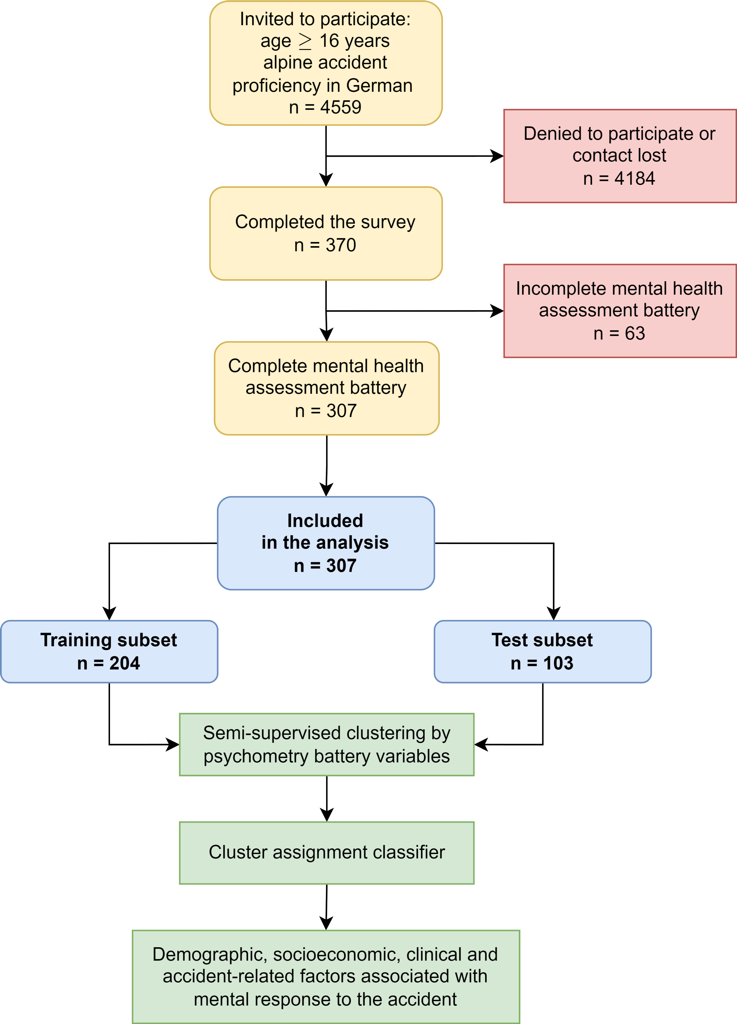

Figure 1: Flow diagram of the analysis inclusion process and the analysis strategy.

**Figure 1. Flow diagram of the analysis inclusion process and the analysis strategy.**

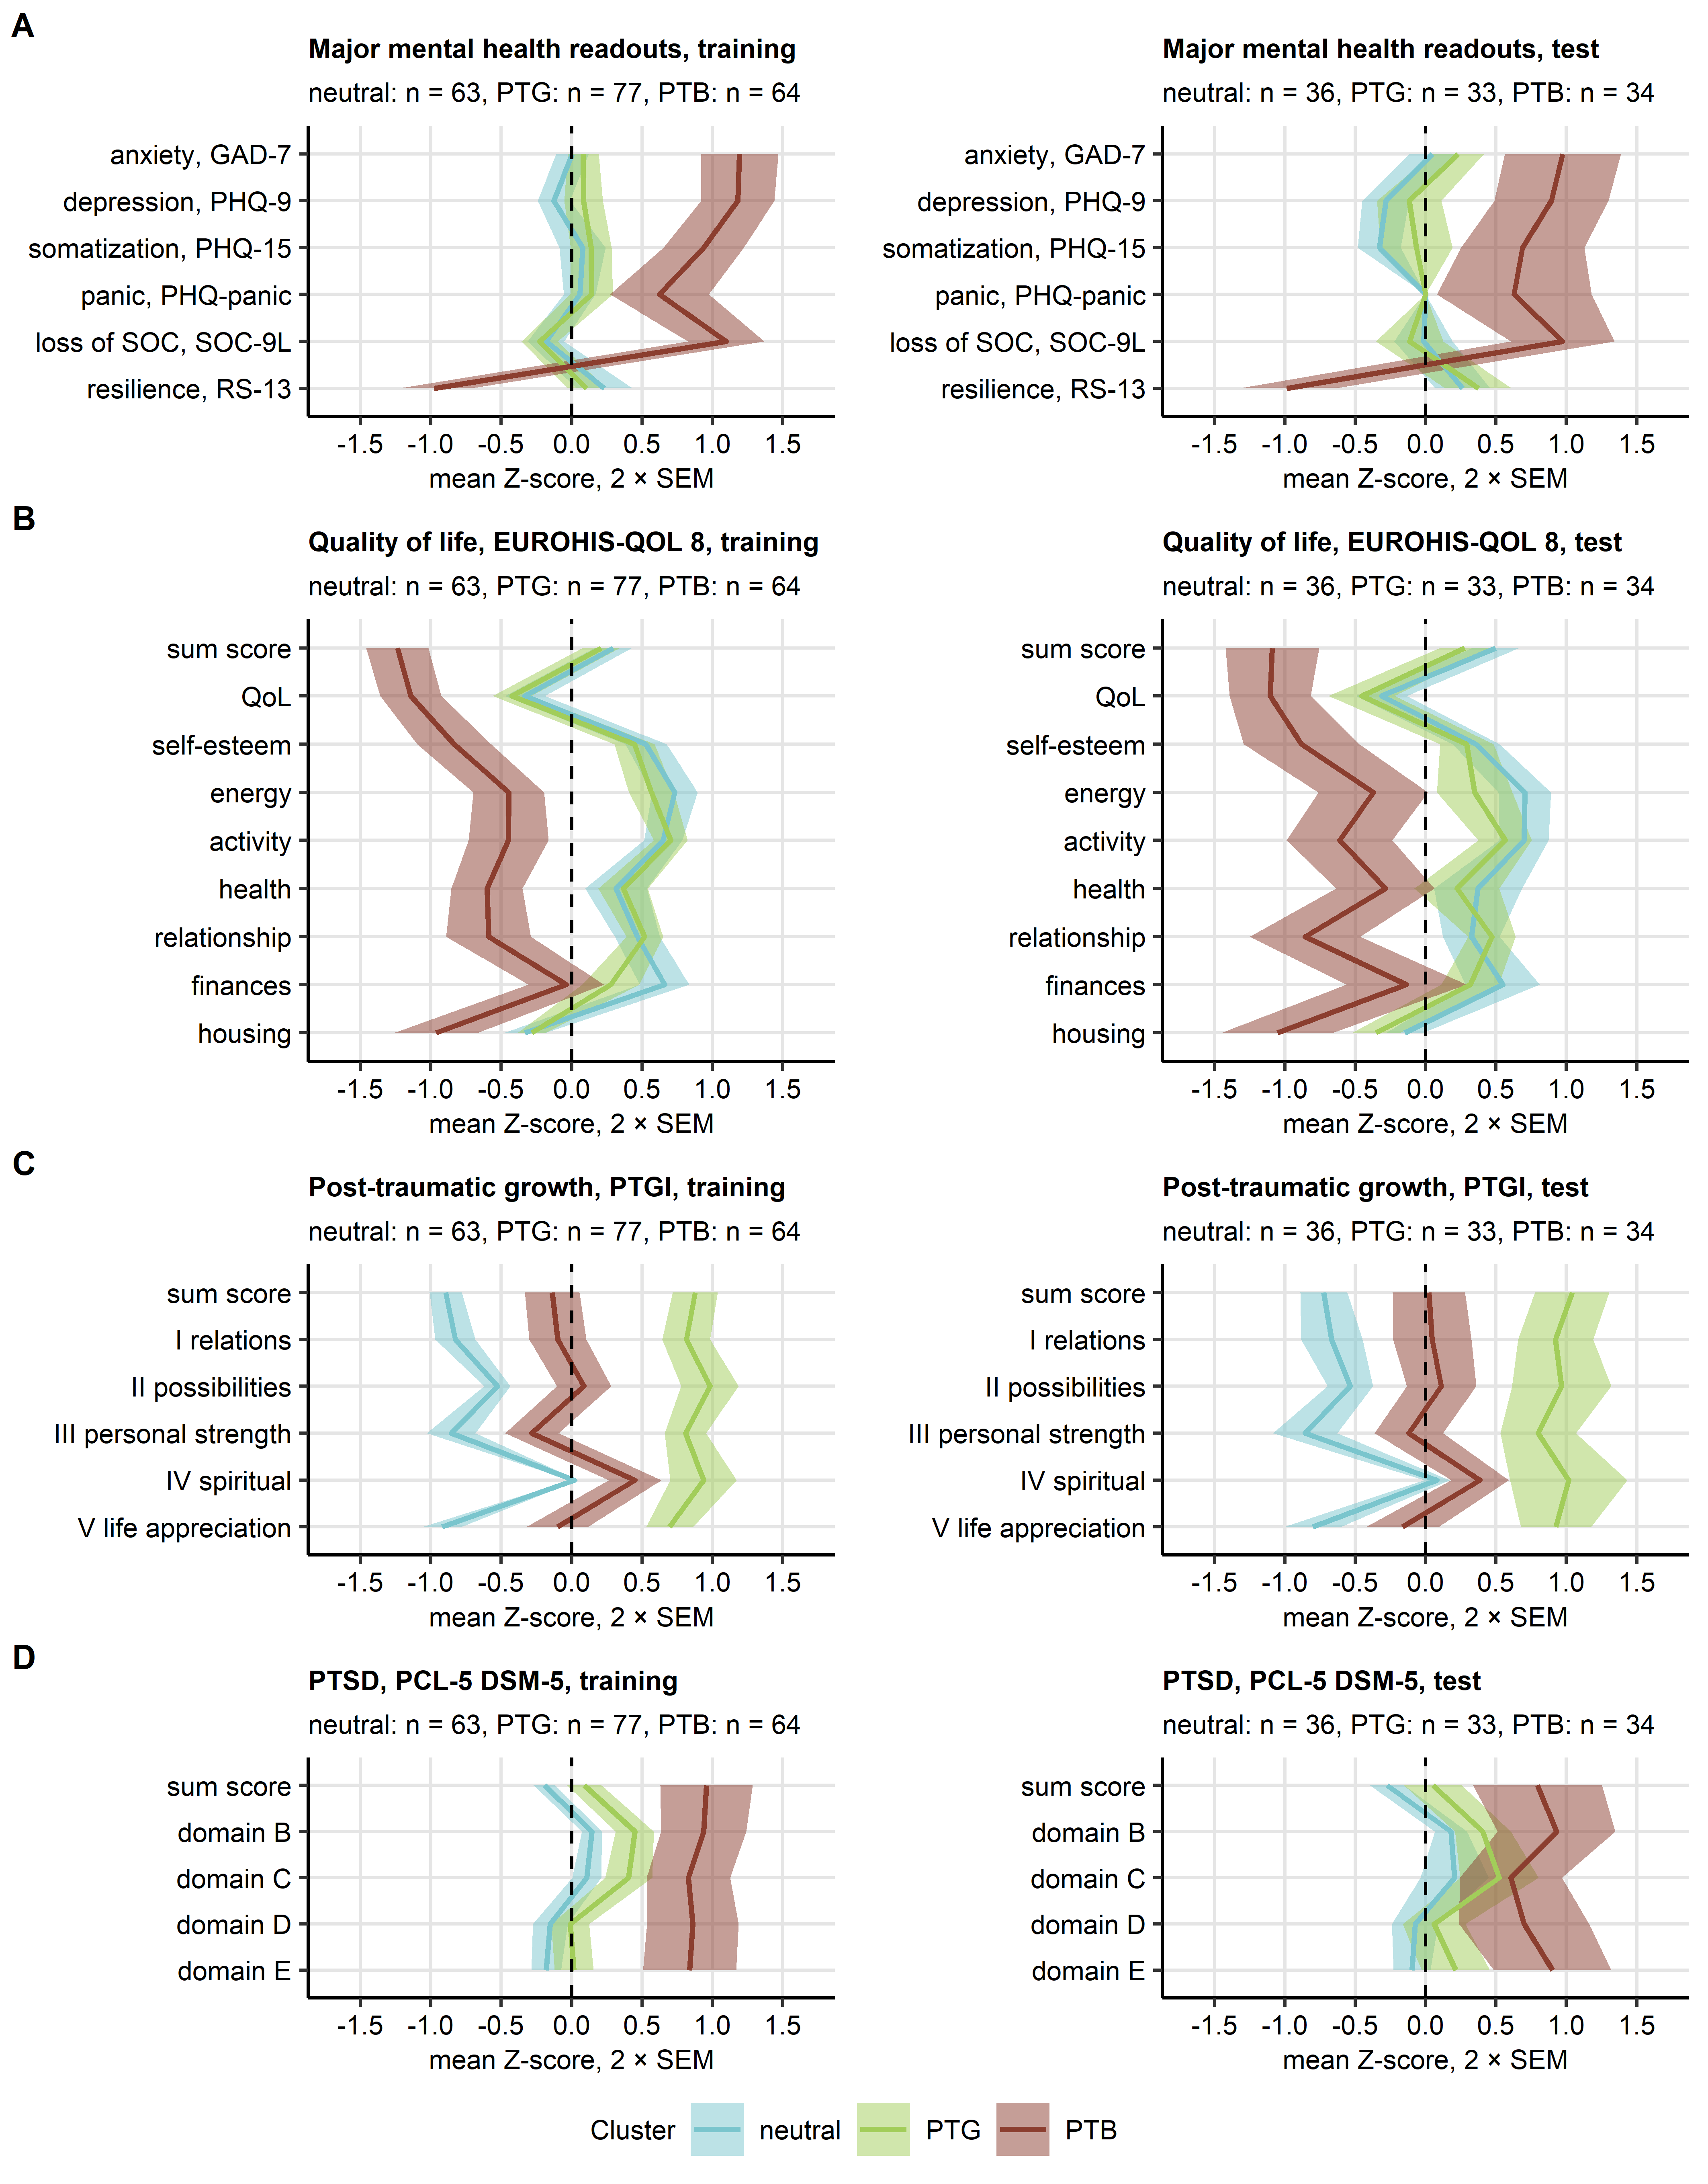

Figure 2: Scores of psychometry readouts in the mental clusters.

**Figure 2. Scores of psychometric assessment in the three mental health clusters.**

*The mental health clusters were defined in respect to psychometric scoring in the training subset of the study cohort by PAM (partition around medoids) with cosine distance between the observations. Assignment of the test subset observations to the mental clusters was done with the inverse distance weighted 7-nearest neighbors classifier. Three mental health clusters were identified: neutral, PTG (post-traumatic growth) and PTS (post-traumatic stress). All clustering parameters differed significantly between the clusters as assessed by Kruskal-Wallis test with effect size statistic. Mean normalized scores of important mental disorders (A), quality of life (B), post-traumatic growth (C) and post-traumatic symptom disorder (D) in the mental health clusters of the training and test subsets of the study cohort are depicted as solid lines. Tinted regions represent 2 SEM (standard error of the mean). Numbers of observations in the clusters are displayed in the plot captions.*

*GAD-7: general anxiety disorder scale of the patient health questionnaire; PHQ-9: patient health questionnaire module for the assessment of depression; PHQ-15: patient health questionnaire module for the assessment of somatization; PHQ panic: patient health questionnaire module for the assessment of symptoms of panic disorder ; EUROHIS-QOL 8: 8-item EUROHIS project quality of life scale; SOC-9L: Leipzig 9-item sense of coherence questionnaire; RS13: 13-item resilience scale; PCL-5: PTSD checklist for DSM-5; PTGI: post-traumatic growth inventory; PTSD: post-traumatic stress disorder.*

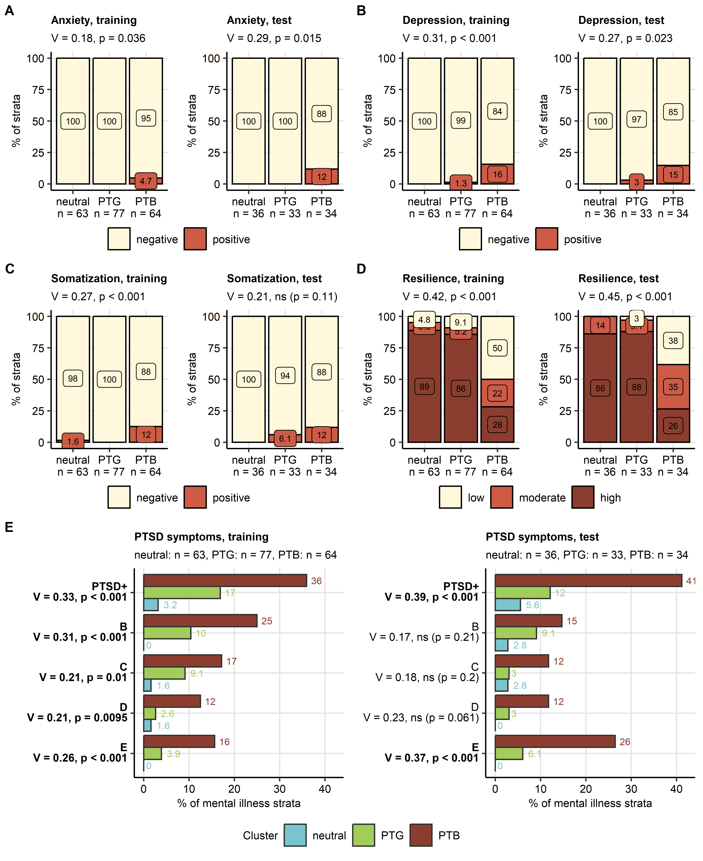

Figure 3: Symptoms of depression, anxiety, somatization, and PTSD as well as resilience in the three mental clusters.

**Figure 3. Symptoms of depression, anxiety, somatization, and PTSD as well as resilience in the three mental health clusters.**

*Frequencies of symptoms of anxiety (A, GAD-7 ≥10), depression (B, PHQ-9 ≥ 11) and somatization (C, PHQ-15 ≥ 11), distribution of resilience(D, RS13) and symptoms of post-traumatic stress disorder (E, PTSD, PCL-5, positivity for PTSD symptom clusters and frequency of participants positive for at least one PTSD symptom cluster [PTSD+]) in the mental health clusters. Statistical significance was determined by test with Cramer V effect size statistic. Fractions of symptom-positive and -negative participants in the mental health clusters in the training and test subset of the study cohort are presented in stack and bar plots. Effect sizes and p-values are shown in the plot captions or Y axes. Numbers of observations in the clusters are shown in the X axes or plot captions. Significant effects in (E) are highlighted in bold. GAD-7: 7-item general anxiety disorder scale; PHQ: patient health questionnaire; RS13: 13-item resilience scale; PCL-5 DSM-5: PTSD checklist for DSM-5; PTSD: post-traumatic stress disorder.*

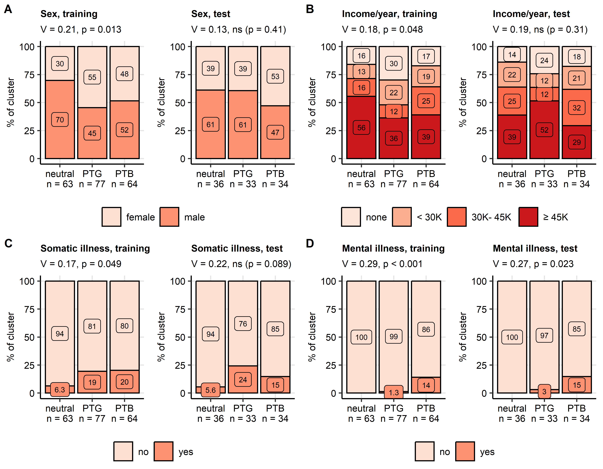

Figure 4: Demographic and clinical factors differing between the mental health response clusters

**Figure 4. Demographic and clinical factors differing between the mental health response clusters**

*Distribution of gender (A), annual household income (B), and frequencies of self-reported pre-existing physical disorders (C) and self-reported pre-existing mental disorders (D) in the mental health clusters. Statistical significance was determined by test with Cramer V effect size statistic. Percentages in the mental clusters in the training and test subset of the study cohort are presented in stack plots. Effect sizes and p-values are displayed in the plot captions. Numbers of observations in the clusters are presented in the X axes.*

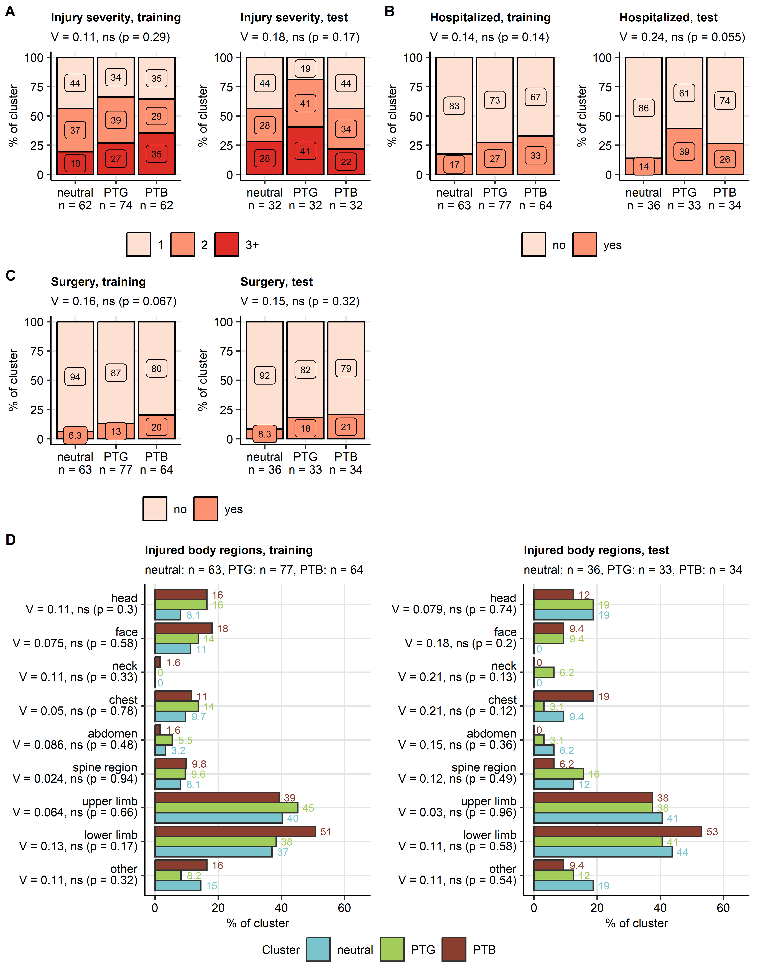

Figure 5: Injury severity and location in the mental health response clusters.

**Figure 5. Injury severity and location in the mental health response clusters.**

*Distribution of injury severity grades (A, AIS: abbreviated injury scale), hospitalization (B) and surgery rates (C), and injuries of the body parts (D) in the mental clusters. Statistical significance was determined by test with Cramer V effect size statistic. Percentages in the mental clusters in the training and test subset of the study cohort are presented in stack and bar plots. Effect sizes and p-values are displayed in the plot captions or Y axes. Numbers of observations in the clusters are presented in the X axes or plot captions.*

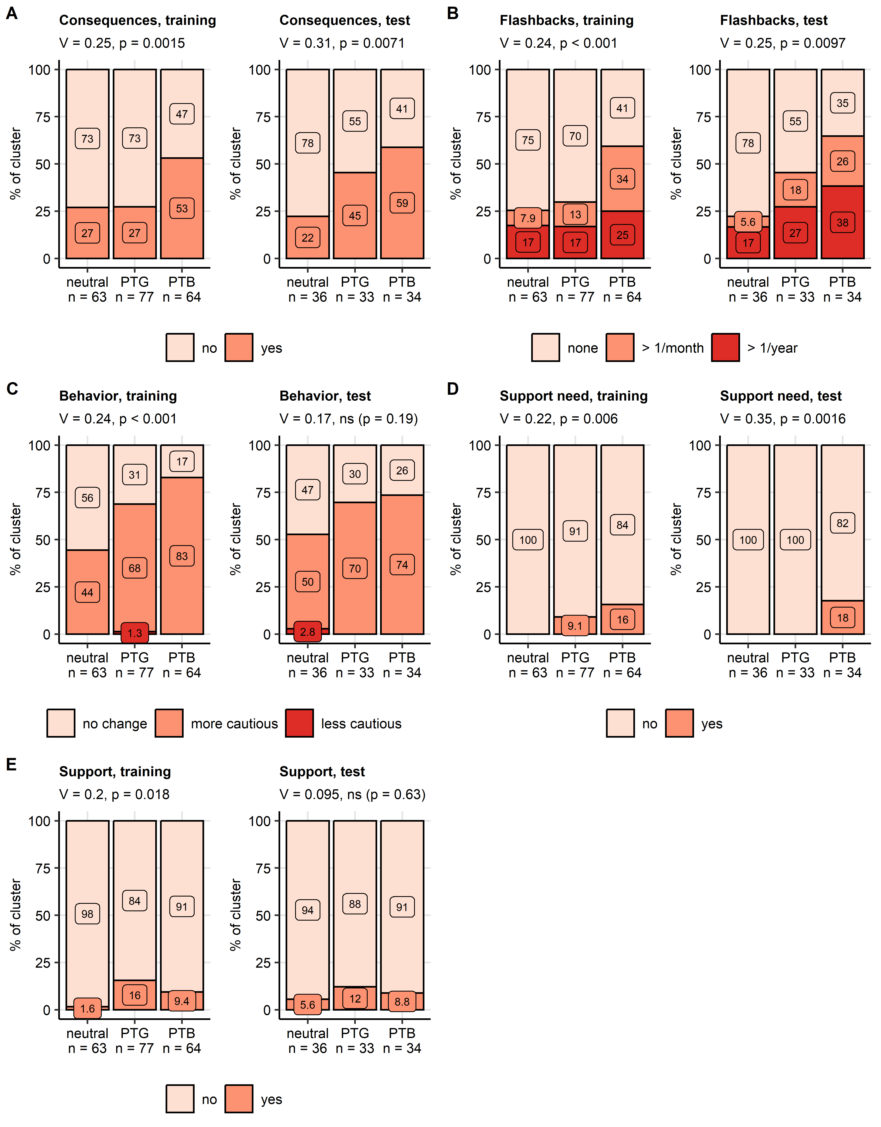

Figure 6: Consequences of the accident in the mental health clusters.

**Figure 6. Persisting physical and mental consequences of the accident in the mental health clusters.**

*Frequencies of persisting physical consequences of the accident (A), flashbacks during same mountain sport (B), more or less cautious behavior during same mountain sport activity (C), self-reported desire for psychological support following the accident (D) and received psychological support (E) in the mental health clusters. Statistical significance was determined by test with Cramer V effect size statistic. Percentages in the mental health response clusters in the training and test subset of the study cohort are presented in stack plots. Effect sizes and p-values are displayed in the plot captions. Numbers of observations in the clusters are presented in the X axes.*

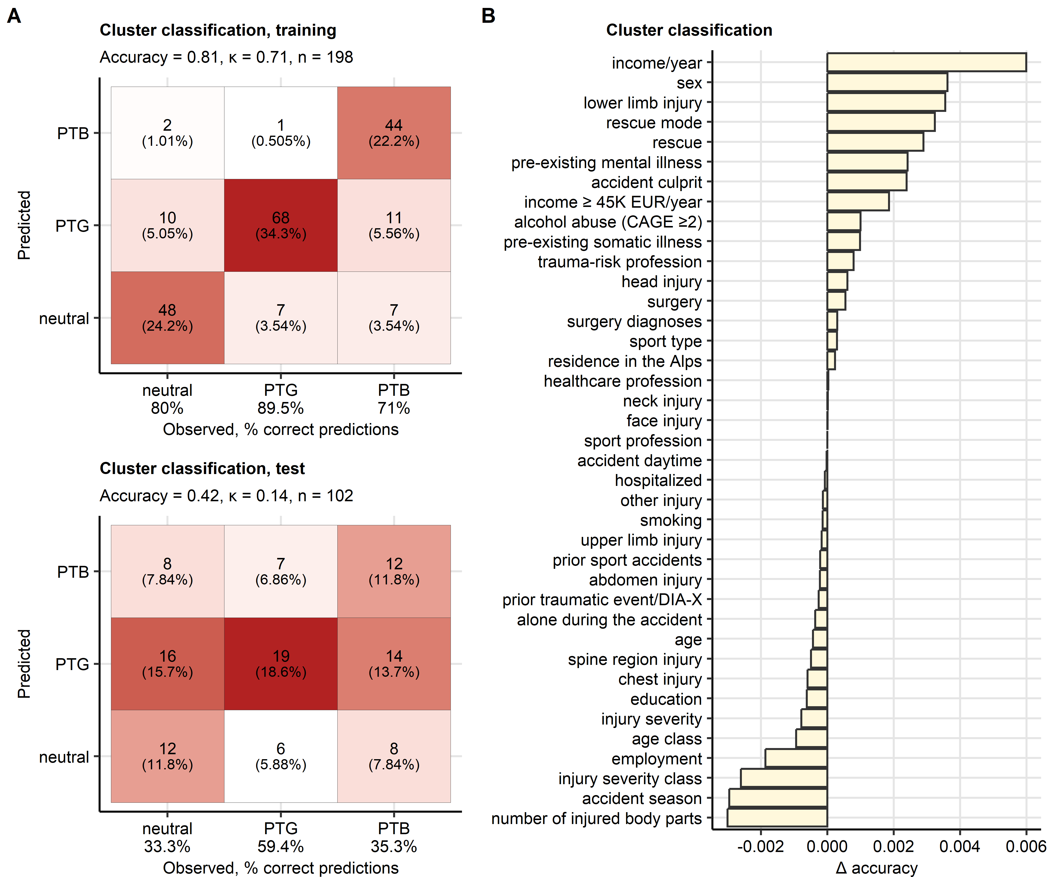

Figure 7: Assignment of accident victims to the mental clusters based on explanatory factors available during acute medical management of the accident.

**Figure 7. Assignment of victims of mountain sports accidents to the mental health clusters based on explanatory factors available during acute medical management of the accident.**

*A conditional random forest classifier for the mental cluster assignment based on demographic, socioeconomic, clinical and accident-related factors available during acute medical management of the accident was trained in the training subset of the study cohort.*

*(A) Prediction accuracy of the classifier in the training and test subset of the study cohort presented in a heat map plot of the confusion matrices. Color codes for number of cases. The overall prediction accuracy, and observation numbers are displayed in the plot caption. Prediction accuracy for particular clusters is shown in the X axis.*

*(B) Conditional importance of the explanatory variables for prediction of the mental cluster assignment expressed as accuracy loss ( accuracy).*

# References

1. American Psychiatric Association. *Diagnostic and Statistical Manual of Mental Disorders*. American Psychiatric Association (2013). doi: [10.1176/appi.books.9780890425596](https://doi.org/10.1176/appi.books.9780890425596)

2. Bryant RA. Post-traumatic stress disorder: a state-of-the-art review of evidence and challenges. *World psychiatry : official journal of the World Psychiatric Association (WPA)* (2019) 18:259–269. doi: [10.1002/WPS.20656](https://doi.org/10.1002/WPS.20656)

3. Howie H, Rijal CM, Ressler KJ. A review of epigenetic contributions to post-traumatic stress disorder. *Dialogues in clinical neuroscience* (2019) 21:417–428. doi: [10.31887/DCNS.2019.21.4/KRESSLER](https://doi.org/10.31887/DCNS.2019.21.4/KRESSLER)

4. Seedat S, Stein DJ, Carey PD. Post-traumatic stress disorder in women: epidemiological and treatment issues. *CNS drugs* (2005) 19:411–427. doi: [10.2165/00023210-200519050-00004](https://doi.org/10.2165/00023210-200519050-00004)

5. Brady KT, Killeen TK, Lucerini S. Comorbidity of Psychiatric Disorders and Posttraumatic Stress Disorder. *The Primary Care Companion for CNS Disorders* (2000) 2:3403. <https://www.psychiatrist.com/pcc/trauma/ptsd/comorbidity-psychiatric-disorders-posttraumatic-stress https://www.psychiatrist.com/jcp/medical/comorbidity/comorbidity-psychiatric-disorders-posttraumatic-stress-2/>

6. Gagnon-Sanschagrin P, Schein J, Urganus A, Serra E, Liang Y, Musingarimi P, Cloutier M, Guérin A, Davis LL. Identifying individuals with undiagnosed post-traumatic stress disorder in a large United States civilian population – a machine learning approach. *BMC Psychiatry* (2022) 22:1–11. doi: [10.1186/S12888-022-04267-6/TABLES/2](https://doi.org/10.1186/S12888-022-04267-6/TABLES/2)

7. Benjet C, Bromet E, Karam EG, Kessler RC, McLaughlin KA, Ruscio AM, Shahly V, Stein DJ, Petukhova M, Hill E, et al. The epidemiology of traumatic event exposure worldwide: results from the World Mental Health Survey Consortium. *Psychological medicine* (2016) 46:327–343. doi: [10.1017/S0033291715001981](https://doi.org/10.1017/S0033291715001981)

8. Breslau N, Wilcox HC, Storr CL, Lucia VC, Anthony JC. Trauma exposure and posttraumatic stress disorder: a study of youths in urban America. *Journal of urban health : bulletin of the New York Academy of Medicine* (2004) 81:530–544. doi: [10.1093/JURBAN/JTH138](https://doi.org/10.1093/JURBAN/JTH138)

9. Van Ameringen M, Mancini C, Patterson B, Boyle MH. Post-traumatic stress disorder in Canada. *CNS neuroscience & therapeutics* (2008) 14:171–181. doi: [10.1111/J.1755-5949.2008.00049.X](https://doi.org/10.1111/J.1755-5949.2008.00049.X)

10. Kessler RC, Berglund P, Demler O, Jin R, Merikangas KR, Walters EE. Lifetime prevalence and age-of-onset distributions of DSM-IV disorders in the National Comorbidity Survey Replication. *Archives of general psychiatry* (2005) 62:593–602. doi: [10.1001/ARCHPSYC.62.6.593](https://doi.org/10.1001/ARCHPSYC.62.6.593)

11. Cloitre M, Stolbach BC, Herman JL, Van Der Kolk B, Pynoos R, Wang J, Petkova E. A developmental approach to complex PTSD: childhood and adult cumulative trauma as predictors of symptom complexity. *Journal of traumatic stress* (2009) 22:399–408. doi: [10.1002/JTS.20444](https://doi.org/10.1002/JTS.20444)

13. Christiansen DM, Berke ET. Gender- and Sex-Based Contributors to Sex Differences in PTSD. *Current Psychiatry Reports* (2020) 22:1–9. doi: [10.1007/S11920-020-1140-Y/METRICS](https://doi.org/10.1007/S11920-020-1140-Y/METRICS)

14. Kongshøj ILL, Berntsen D. Is Young Age a Risk Factor for PTSD? Age Differences in PTSD-Symptoms After Hurricane Florence. *Traumatology* (2022) doi: [10.1037/TRM0000389](https://doi.org/10.1037/TRM0000389)

15. Papini S, Pisner D, Shumake J, Powers MB, Beevers CG, Rainey EE, Smits JAJ, Warren AM. Ensemble machine learning prediction of posttraumatic stress disorder screening status after emergency room hospitalization. *Journal of anxiety disorders* (2018) 60:35–42. doi: [10.1016/J.JANXDIS.2018.10.004](https://doi.org/10.1016/J.JANXDIS.2018.10.004)

16. Galatzer-Levy IR, Karstoft KI, Statnikov A, Shalev AY. Quantitative Forecasting of PTSD from Early Trauma Responses: A Machine Learning Application. *Journal of psychiatric research* (2014) 59:68. doi: [10.1016/J.JPSYCHIRES.2014.08.017](https://doi.org/10.1016/J.JPSYCHIRES.2014.08.017)

17. Tedeschi RG, Calhoun LG. The Posttraumatic Growth Inventory: measuring the positive legacy of trauma. *Journal of traumatic stress* (1996) 9:455–471. doi: [10.1007/BF02103658](https://doi.org/10.1007/BF02103658)

18. Agaibi CE, Wilson JP. Trauma, PTSD, and resilience: a review of the literature. *Trauma, violence & abuse* (2005) 6:195–216. doi: [10.1177/1524838005277438](https://doi.org/10.1177/1524838005277438)

19. Levine SZ, Laufer A, Stein E, Hamama-Raz Y, Solomon Z. Examining the relationship between resilience and posttraumatic growth. *Journal of traumatic stress* (2009) 22:282–286. doi: [10.1002/JTS.20409](https://doi.org/10.1002/JTS.20409)

20. Bensimon M. Elaboration on the association between trauma, PTSD and posttraumatic growth: The role of trait resilience. *Personality and Individual Differences* (2012) 52:782–787. doi: [10.1016/J.PAID.2012.01.011](https://doi.org/10.1016/J.PAID.2012.01.011)

21. Niedermeier M, Hartl A, Kopp M. Prevalence of Mental Health Problems and Factors Associated with Psychological Distress in Mountain Exercisers: A Cross-Sectional Study in Austria. *Frontiers in psychology* (2017) 8: doi: [10.3389/FPSYG.2017.01237](https://doi.org/10.3389/FPSYG.2017.01237)

22. Niedermeier M, Einwanger J, Hartl A, Kopp M. Affective responses in mountain hiking-A randomized crossover trial focusing on differences between indoor and outdoor activity. *PloS one* (2017) 12: doi: [10.1371/JOURNAL.PONE.0177719](https://doi.org/10.1371/JOURNAL.PONE.0177719)

23. Faulhaber M, Pocecco E, Posch M, Ruedl G. Accidents during mountain hiking and alpine skiing – epidemiological data from the Austrian alps. *Deutsche Zeitschrift fur Sportmedizin* (2020) 71:293–299. doi: [10.5960/DZSM.2020.465](https://doi.org/10.5960/DZSM.2020.465)

24. Segal DL. Diagnostic and Statistical Manual of Mental Disorders ( DSM ‐ IV ‐ TR ) . *The Corsini Encyclopedia of Psychology* (2010)1–3. doi: [10.1002/9780470479216.CORPSY0271](https://doi.org/10.1002/9780470479216.CORPSY0271)

25. Joseph NM, Benedick A, Flanagan CD, Breslin MA, Simpson M, Ragone C, Kalina M, Hendrickson SB, Vallier HA. Prevalence of posttraumatic stress disorder in acute trauma patients. *OTA international : the open access journal of orthopaedic trauma* (2020) 3:e056. doi: [10.1097/OI9.0000000000000056](https://doi.org/10.1097/OI9.0000000000000056)

26. Sommer I, Ehlert U. Adjustment to trauma exposure: Prevalence and predictors of posttraumatic stress disorder symptoms in mountain guides. *Journal of Psychosomatic Research* (2004) 57:329–335. doi: [10.1016/j.jpsychores.2004.01.010](https://doi.org/10.1016/j.jpsychores.2004.01.010)

27. Mikutta C, Schmid JJ, Ehlert U. Resilience and Post-traumatic Stress Disorder in the Swiss Alpine Rescue Association. *Frontiers in psychiatry* (2022) 13: doi: [10.3389/FPSYT.2022.780498](https://doi.org/10.3389/FPSYT.2022.780498)

28. Traber D, Le Barbenchon E, Hot P, Pellissier S. Perspectives about the PTSD prevalence rate in the case of multiple traumatic events exposure among mountain workers. *European Journal of Trauma & Dissociation* (2020) 4:100109. doi: [10.1016/J.EJTD.2019.05.002](https://doi.org/10.1016/J.EJTD.2019.05.002)

29. Thordardottir EB, Valdimarsdottir UA, Hansdottir I, Resnick H, Shipherd JC, Gudmundsdottir B. Posttraumatic stress and other health consequences of catastrophic avalanches: A 16-year follow-up of survivors. *Journal of anxiety disorders* (2015) 32:103–111. doi: [10.1016/J.JANXDIS.2015.03.005](https://doi.org/10.1016/J.JANXDIS.2015.03.005)

30. Léonard C, Charriau-Perret A, Debaty G, Belle L, Ricard C, Sanchez C, Dupré PM, Panoff G, Bougerol T, Viglino D, et al. Survivors of avalanche accidents: posttraumatic stress disorder symptoms and quality of life: a multicentre study. *Scandinavian Journal of Trauma, Resuscitation and Emergency Medicine* (2021) 29:1–11. doi: [10.1186/S13049-021-00912-3/FIGURES/2](https://doi.org/10.1186/S13049-021-00912-3/FIGURES/2)

31. Spitzer RL, Kroenke K, Williams JBW, Löwe B. A Brief Measure for Assessing Generalized Anxiety Disorder: The GAD-7. *Archives of Internal Medicine* (2006) 166:1092–1097. doi: [10.1001/ARCHINTE.166.10.1092](https://doi.org/10.1001/ARCHINTE.166.10.1092)

32. Löwe B, Spitzer RL, Zipfel S, Herzog W. Auflage Manual 17.07. (2002).

33. Gräfe K, Zipfel S, Herzog W, Löwe B. Screening psychischer störungen mit dem "Gesundheitsfragebogen für Patienten (PHQ-D)". Ergebnisse der Deutschen validierungsstudie. *Diagnostica* (2004) 50:171–181. doi: [10.1026/0012-1924.50.4.171](https://doi.org/10.1026/0012-1924.50.4.171)

34. Kroenke K, Spitzer RL, Williams JBW. The PHQ-15: validity of a new measure for evaluating the severity of somatic symptoms. *Psychosomatic medicine* (2002) 64:258–266. doi: [10.1097/00006842-200203000-00008](https://doi.org/10.1097/00006842-200203000-00008)

35. Leppert K, Koch B, Brähler E, Und BS-KD, 2008 U. Die Resilienzskala (RS)–Überprüfung der Langform RS-25 und einer Kurzform RS-13. *Klinische Diagnostik und Evaluation* (2008) 1:226–243. <https://www.academia.edu/download/44388154/A_406.pdf>

36. Schumacher J, Wilz G, Gunzelmann T, Brähler E. Die sense of coherence scale von antonovsky: Teststatische überprüfung in einer repräsentativen bevölkerungsstichprobe und konstruktion einer kurzskala. *PPmP Psychotherapie Psychosomatik Medizinische Psychologie* (2000) 50:472–482. doi: [10.1055/s-2000-9207](https://doi.org/10.1055/s-2000-9207)

37. Schmidt S, Mühlan H, Power M. The EUROHIS-QOL 8-item index: psychometric results of a cross-cultural field study. *European Journal of Public Health* (2006) 16:420–428. doi: [10.1093/EURPUB/CKI155](https://doi.org/10.1093/EURPUB/CKI155)

38. Bovin MJ, Marx BP, Weathers FW, Gallagher MW, Rodriguez P, Schnurr PP, Keane TM. Psychometric properties of the PTSD Checklist for Diagnostic and Statistical Manual of Mental Disorders-Fifth Edition (PCL-5) in veterans. *Psychological assessment* (2016) 28:1379–1391. doi: [10.1037/PAS0000254](https://doi.org/10.1037/PAS0000254)

39. McDonald RP. *Test theory: A unified treatment*. 1st Editio. New Yor: Psychology Press (1999). doi: [10.4324/9781410601087](https://doi.org/10.4324/9781410601087)

40. Manea L, Gilbody S, McMillan D. Optimal cut-off score for diagnosing depression with the Patient Health Questionnaire (PHQ-9): A meta-analysis. *CMAJ* (2012) 184:E191. doi: [10.1503/CMAJ.110829/-/DC1](https://doi.org/10.1503/CMAJ.110829/-/DC1)

41. Maercker A, Bromberger F. Checklisten und Fragebogen zur Erfassung traumatischer Ereignisse in deutscher Sprache. *Trierer Psychologische Berichte* (2005) 32:

42. O’Brien CP. The CAGE Questionnaire for Detection of Alcoholism. *JAMA* (2008) 300:2054–2056. doi: [10.1001/JAMA.2008.570](https://doi.org/10.1001/JAMA.2008.570)

43. Gennarelli TA, Wodzin E. AIS 2005: A contemporary injury scale. *Injury* (2006) 37:1083–1091. doi: [10.1016/j.injury.2006.07.009](https://doi.org/10.1016/j.injury.2006.07.009)

44. Kassambara A, Mundt F. factoextra: Extract and Visualize the Results of Multivariate Data Analyses. (2020) <https://cran.r-project.org/web/packages/factoextra/index.html>

45. Kassambara A. rstatix: Pipe-Friendly Framework for Basic Statistical Tests. (2021) <https://cran.r-project.org/package=rstatix>

46. Drost H-G. Philentropy: Information Theory and Distance Quantification with R. *Journal of Open Source Software* (2018) 3:765. doi: [10.21105/joss.00765](https://doi.org/10.21105/joss.00765)

47. Schubert E, Rousseeuw PJ. Faster k-Medoids Clustering: Improving the PAM, CLARA, and CLARANS Algorithms. *Lecture notes in computer science (including subseries lecture notes in artificial intelligence and lecture notes in bioinformatics)*. Springer (2019). p. 171–187 doi: [10.1007/978-3-030-32047-8_16](https://doi.org/10.1007/978-3-030-32047-8_16)

48. Lange T, Roth V, Braun ML, Buhmann JM. Stability-based validation of clustering solutions. *Neural Computation* (2004) 16:1299–1323. doi: [10.1162/089976604773717621](https://doi.org/10.1162/089976604773717621)

49. Rousseeuw PJ. Silhouettes: A graphical aid to the interpretation and validation of cluster analysis. *Journal of Computational and Applied Mathematics* (1987) 20:53–65. doi: [10.1016/0377-0427(87)90125-7](https://doi.org/10.1016/0377-0427(87)90125-7)

50. Hothorn T, Hornik K, Zeileis A. Unbiased recursive partitioning: A conditional inference framework. *Journal of Computational and Graphical Statistics* (2006) 15:651–674. doi: [10.1198/106186006X133933](https://doi.org/10.1198/106186006X133933)

51. Strobl C, Boulesteix AL, Zeileis A, Hothorn T. Bias in random forest variable importance measures: Illustrations, sources and a solution. *BMC Bioinformatics* (2007) 8:1–21. doi: [10.1186/1471-2105-8-25/FIGURES/11](https://doi.org/10.1186/1471-2105-8-25/FIGURES/11)

52. Hothorn T, Hornik K, Strobl C, Zeileis A. party: A Laboratory for Recursive Partytioning. (2022) <https://cran.r-project.org/web/packages/party/index.html>

53. Kuhn M. Building predictive models in R using the caret package. *Journal of Statistical Software* (2008) 28:1–26. doi: [10.18637/jss.v028.i05](https://doi.org/10.18637/jss.v028.i05)

54. Strobl C, Boulesteix AL, Kneib T, Augustin T, Zeileis A. Conditional variable importance for random forests. *BMC Bioinformatics* (2008) 9:1–11. doi: [10.1186/1471-2105-9-307/FIGURES/4](https://doi.org/10.1186/1471-2105-9-307/FIGURES/4)

55. Statistik Austria. Rauchen - STATISTIK AUSTRIA - Die Informationsmanager. (2022) <https://www.statistik.at/statistiken/bevoelkerung-und-soziales/gesundheit/gesundheitsverhalten/rauchen> [Accessed February 24, 2023]

56. Statistik Austria. Gesundheitszustand selbstberichtet - STATISTIK AUSTRIA - Die Informationsmanager. (2022) <https://www.statistik.at/statistiken/bevoelkerung-und-soziales/gesundheit/gesundheitszustand/gesundheitszustand-selbstberichtet> [Accessed February 24, 2023]

1. Ower C, Kemmler G, Vill T, Martini C, Schmitt A, Sperner-Unterweger B, et al. The effect of physical activity in an alpine environment on quality of life is mediated by resilience in patients with psychosomatic disorders and healthy controls. European Archives of Psychiatry and Clinical Neuroscience. 2019;269:543-53.

2. Sommer I, Ehlert U. Adjustment to trauma exposure: Prevalence and predictors of posttraumatic stress disorder symptoms in mountain guides. Journal of psychosomatic research. 2004;57(4):329-35.

3. Léonard C, Charriau-Perret A, Debaty G, Belle L, Ricard C, Sanchez C, et al. Survivors of avalanche accidents: posttraumatic stress disorder symptoms and quality of life: a multicentre study. Scandinavian journal of trauma, resuscitation and emergency medicine. 2021;29(1):1-11.

4. Mikutta C, Schmid JJ, Ehlert U. Resilience and Post-traumatic Stress Disorder in the Swiss Alpine Rescue Association. Front Psychiatry. 2022;13:780498.

5. Liu AN, Wang LL, Li HP, Gong J, Liu XH. Correlation Between Posttraumatic Growth and Posttraumatic Stress Disorder Symptoms Based on Pearson Correlation Coefficient: A Meta-Analysis. J Nerv Ment Dis. 2017;205(5):380-9.

6. [https://www.ptsd.va.gov/understand/common/common_adults.asp#:~:text=About%206%20out%20of%20every,criteria%20for%20PTSD%20after%20treatment](https://www.ptsd.va.gov/understand/common/common_adults.asp" \l ":~:text=About 6 out of every,criteria for PTSD after treatment).

7. ([https://icd.who.int/browse11/l-m/en#/http://id.who.int/icd/entity/2070699808](https://icd.who.int/browse11/l-m/en" \l "/http://id.who.int/icd/entity/2070699808)).

8. van der Velden PG, Bosmans MW, Scherpenzeel AC. The burden of research on trauma for respondents: a prospective and comparative study on respondents evaluations and predictors. PLoS One. 2013;8(10):e77266.

9. Cheung KL, Ten Klooster PM, Smit C, de Vries H, Pieterse ME. The impact of non-response bias due to sampling in public health studies: A comparison of voluntary versus mandatory recruitment in a Dutch national survey on adolescent health. BMC Public Health. 2017;17(1):276.